I. Virtual Box
1. Grab Virtual box Linux version from https://www.virtualbox.org/wiki/Linux_Downloads and install it.
2. Download .deb package of ubuntu desktop
3. Create VM and install Ubuntu , using instruction from https://www.virtualbox.org/manual/ch01.html#intro-running
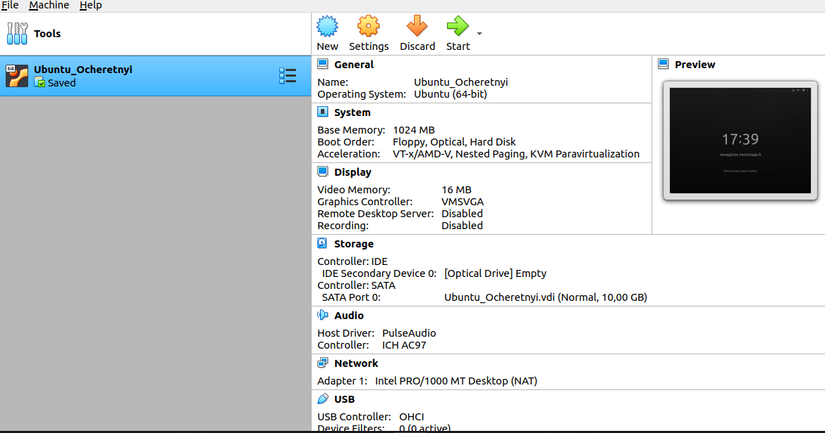

4. Start , stop, reboot, save state VM

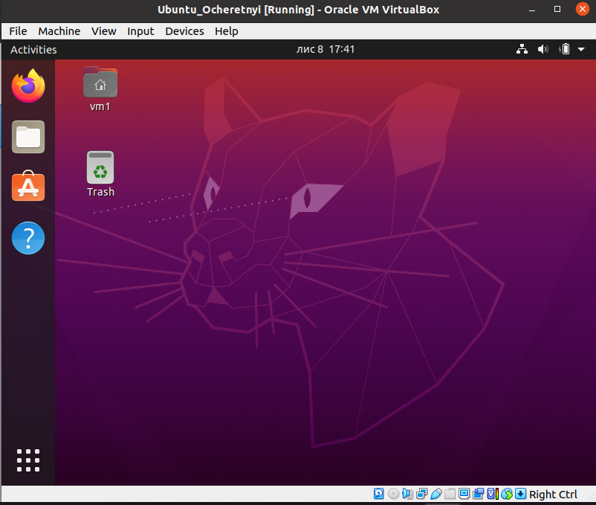

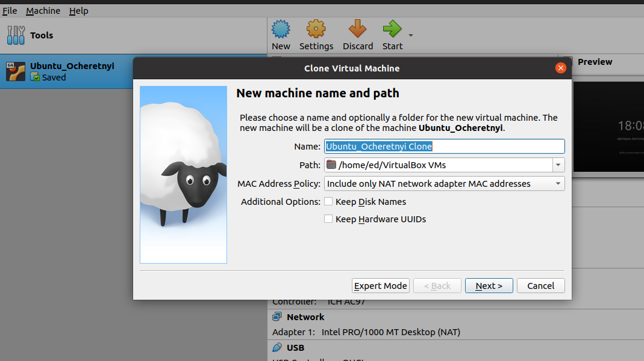
5. Clone VM based on existed VM
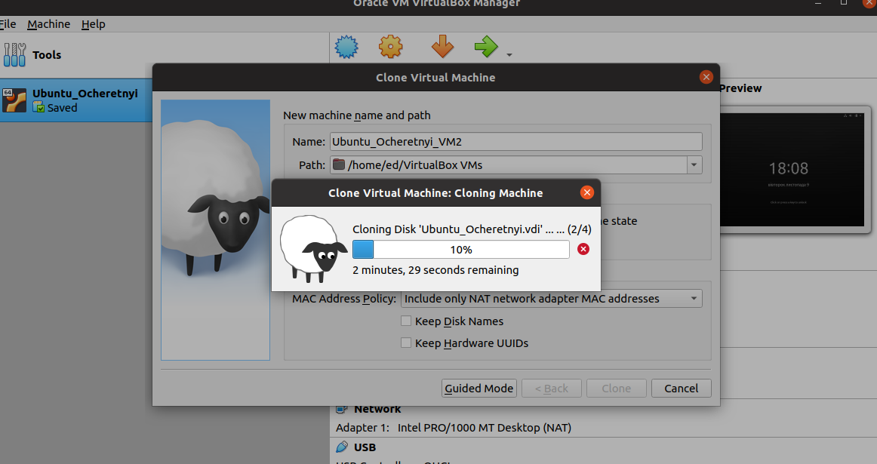
6. Create a group of 2 machines

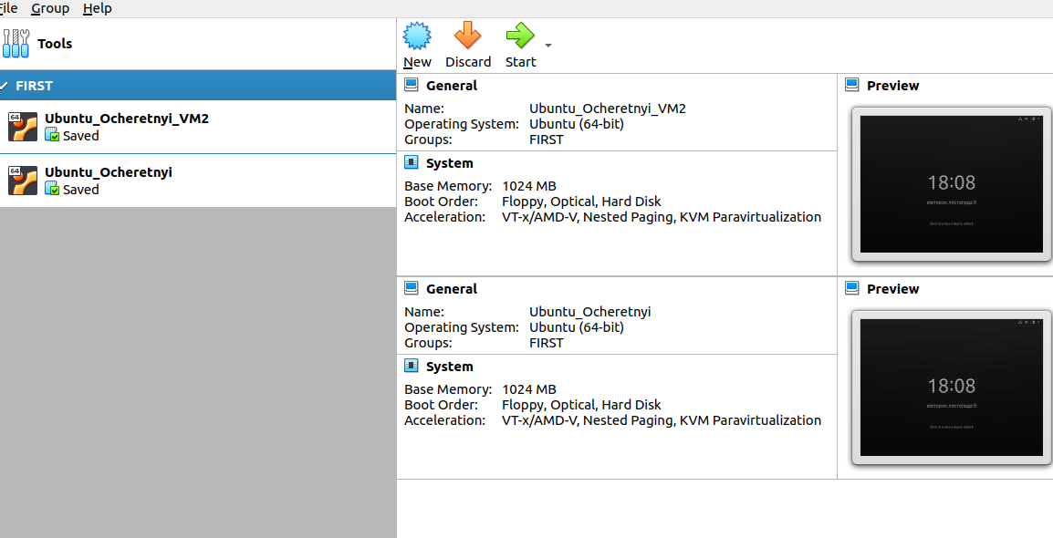

7. Working with snapshots, creating snapshot tree
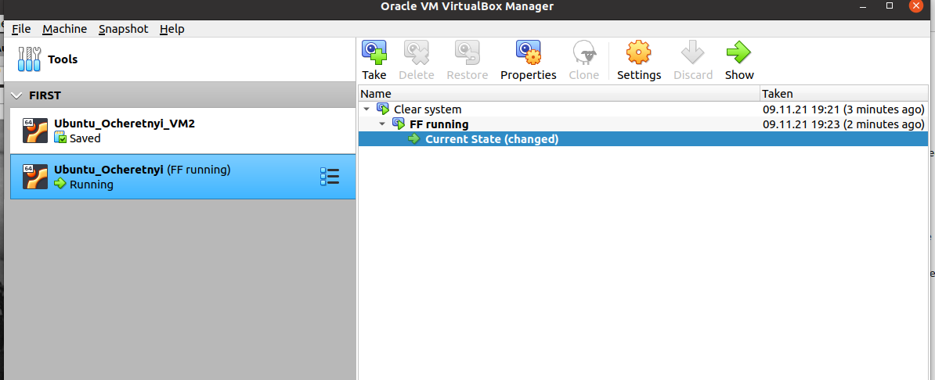

8. Export / Import VM into/from .ova file

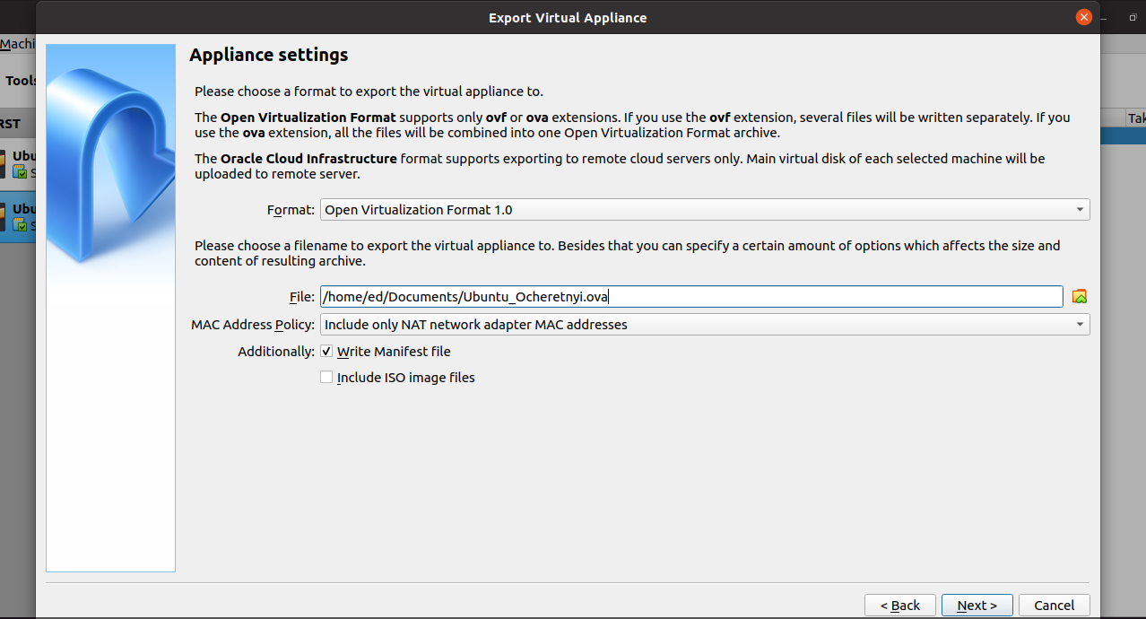

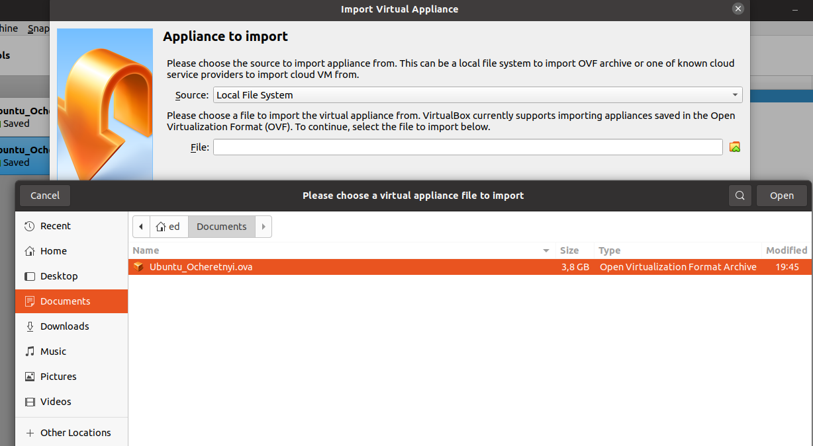

9. Create shared folder as connection VM with host
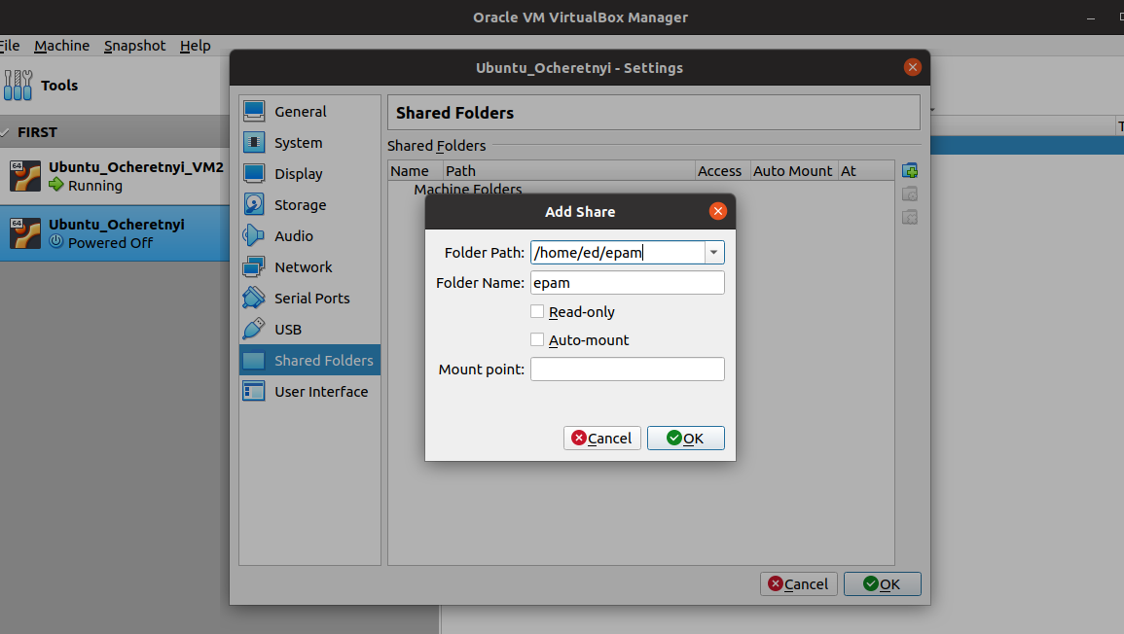

10. Configure different network modes
10.1NAT
Ping router
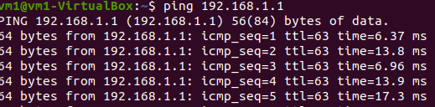
Ping google
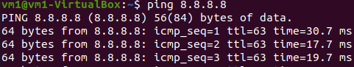

Ping host
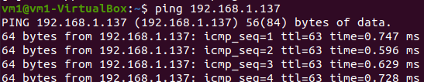
11. Work with VboxManage via CLI

showvminfo

.
createvm

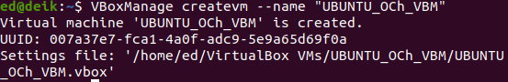
startvm
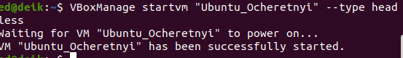

controlvm
snapshot
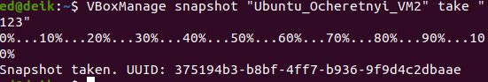
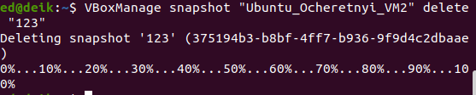
clonevm
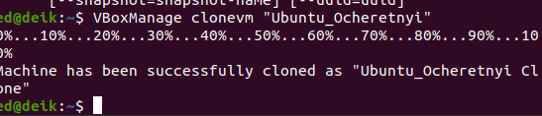

II. VAGRANT
1. vagrant init, vagrant up

ed@deik:~/epam/DevOps_online_Kiev_2021Q4/m2/task2.1/eduard_ocheretnyi$ vagrant init hashicorp/bionic64
A `Vagrantfile` has been placed in this directory. You are now
ready to `vagrant up` your first virtual environment! Please read
the comments in the Vagrantfile as well as documentation on
`vagrantup.com` for more information on using Vagrant.
ed@deik:~/epam/DevOps_online_Kiev_2021Q4/m2/task2.1/eduard_ocheretnyi$ vagrant up
Bringing machine 'default' up with 'virtualbox' provider...
==> default: Box 'hashicorp/bionic64' could not be found. Attempting to find and install...
default: Box Provider: virtualbox
default: Box Version: >= 0
==> default: Loading metadata for box 'hashicorp/bionic64'
default: URL: https://vagrantcloud.com/hashicorp/bionic64
==> default: Adding box 'hashicorp/bionic64' (v1.0.282) for provider: virtualbox
default: Downloading: https://vagrantcloud.com/hashicorp/boxes/bionic64/versions/1.0.282/providers/virtualbox.box
==> default: Box download is resuming from prior download progress
default: Download redirected to host: vagrantcloud-files-production.s3-accelerate.amazonaws.com
==> default: Successfully added box 'hashicorp/bionic64' (v1.0.282) for 'virtualbox'!
==> default: Importing base box 'hashicorp/bionic64'...
==> default: Matching MAC address for NAT networking...
==> default: Checking if box 'hashicorp/bionic64' version '1.0.282' is up to date...
==> default: Setting the name of the VM: eduard_ocheretnyi_default_1636632754045_31011
Vagrant is currently configured to create VirtualBox synced folders with
the `SharedFoldersEnableSymlinksCreate` option enabled. If the Vagrant
guest is not trusted, you may want to disable this option. For more
information on this option, please refer to the VirtualBox manual:

https://www.virtualbox.org/manual/ch04.html#sharedfolders

This option can be disabled globally with an environment variable:

VAGRANT_DISABLE_VBOXSYMLINKCREATE=1

or on a per folder basis within the Vagrantfile:

config.vm.synced_folder '/host/path', '/guest/path', SharedFoldersEnableSymlinksCreate: false
==> default: Clearing any previously set network interfaces...
==> default: Preparing network interfaces based on configuration...
default: Adapter 1: nat
==> default: Forwarding ports...
default: 22 (guest) => 2222 (host) (adapter 1)
==> default: Booting VM...
==> default: Waiting for machine to boot. This may take a few minutes...
default: SSH address: 127.0.0.1:2222
default: SSH username: vagrant
default: SSH auth method: private key
default: Warning: Connection reset. Retrying...
default: Warning: Remote connection disconnect. Retrying...
default:
default: Vagrant insecure key detected. Vagrant will automatically replace
default: this with a newly generated keypair for better security.
default:
default: Inserting generated public key within guest...
default: Removing insecure key from the guest if it's present...
default: Key inserted! Disconnecting and reconnecting using new SSH key...
==> default: Machine booted and ready!
==> default: Checking for guest additions in VM...
default: The guest additions on this VM do not match the installed version of
default: VirtualBox! In most cases this is fine, but in rare cases it can
default: prevent things such as shared folders from working properly. If you see
default: shared folder errors, please make sure the guest additions within the
default: virtual machine match the version of VirtualBox you have installed on
default: your host and reload your VM.
default:
default: Guest Additions Version: 6.0.10
default: VirtualBox Version: 6.1
==> default: Mounting shared folders...
default: /vagrant => /home/ed/epam/DevOps_online_Kiev_2021Q4/m2/task2.1/eduard_ocheretnyi

2. PuTTY
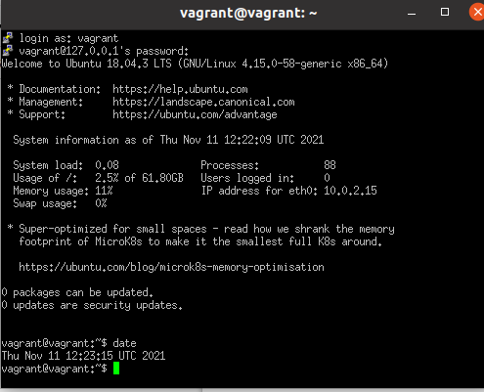

3. vagrant halt, vagrant destroy
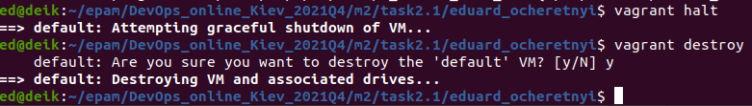

4. Created my vagrant box using WebUI interfaces

https://app.vagrantup.com/o4edik/boxes/task2.1/versions/1.0

